GUI

1. /Users/tzuuu/Documents/GUI_0417/object_detection_model/original
   1. 採用E:\klt\yolo_v13_0506\runs\obb\中文標籤\weights\best.pt
   2. 資料擴增400/95
2. /Users/tzuuu/Documents/GUI_0417/object_detection_model/GH
   1. 採用"E:\klt\yolo_v13_0506_GH2.5_CBW\runs\obb\中文標籤\weights\best.pt"
   2. 資料擴增400/95
   3. 高斯2.5
   4. 像素反轉
3. /Users/tzuuu/Documents/GUI_0417/object_detection_model/AHE
   1. 採用"E:\klt\yolo_v13_0506_LT_AHE44\runs\obb\train2\weights\best.pt"
   2. 資料擴增400/95
   3. 線性變換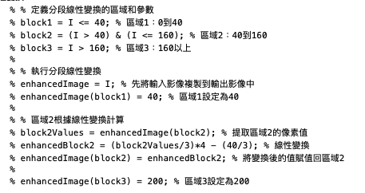
   4. 自適應44
4. /Users/tzuuu/Documents/GUI_0417/object_detection_model/GH+AHE
   1. 採用"E:\klt\yolo_v13_0506_FC20_AHE42\runs\obb\中文標籤\weights\best.pt"
   2. 資料擴增400/95
   3. 平場矯正 20
   4. 自適應42